**::CIS 25 Fall 2016:: Assignment 10 Nested Loops**

**Student ID:** 10831438

How does a **for** loop with multiple loop control variables operate?

Explain the execution of the following Nested **for** loops

for (int i = 1; i < 5; i++){

System.out.println("Outer Loop " + i);

for (int j = 1; j < i; j++, j++)

System.out.println("Inner Loop " + j);

Explain the execution of the following Nested **while** loops

for (int a =0; a <3; a++){

System.out.println("Outer loop count: " + a);

System.out.print(" Inner loop count: ");

int t = 0;

while(t<100){

if(t == 10) break;

System.out.print(t + " ");

t++; }

System.out.println();

}

System.out.println("Loops complete");

Create a multiplication table for numbers 1 – 9,and all the multiples up to 9.

Use a Nested **for** Loop to print the table.

**Formatting is key for this assignment**, your output should exactly match the output below. Use escape sequences etc, as necessary.

Expected Output

Multiplication Table

1 2 3 4 5 6 7 8 9

---------------------------------------------------------

1| 1 2 3 4 5 6 7 8 9

2| 2 4 6 8 10 12 14 16 18

3| 3 6 9 12 15 18 21 24 27

4| 4 8 12 16 20 24 28 32 36

5| 5 10 15 20 25 30 35 40 45

6| 6 12 18 24 30 36 42 48 54

Etc...

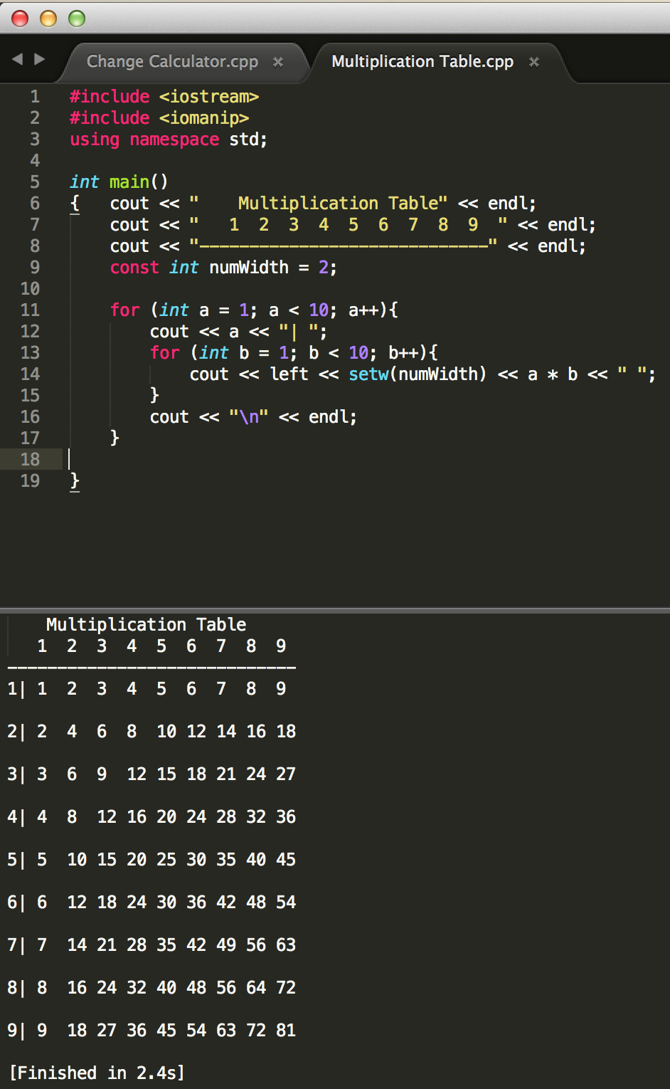

Print the following combination of stars using a **for** loop nested inside a **for** loop. Then a **while** loop nested inside a **for** loop. You are welcome to use as many nested loops as it takes to solve the problem.

Each letter will have two separate programs that produce the same output.

Attach Snipping photo of the source code for all 6 exercises and output.

A.

*****

****

***

**

*

B.

*

**

***

****

*****

C.

**********

********

******

****

**